# Python and Bash Assessment:

**1. Grade Checker**

**Take a score as input and print the grade based on the following:**

**90+ : "A"**

**80-89 : "B"**

**70-79 : "C"**

**60-69 : "D"**

**Below 60 : "F"**

**here we used a basic if else statement to carry out marks and all.**

**Answer :**

**INPUT:**

score = int(input("Enter your score (0-100): "))

# Check grade using if-else

if score >= 90:

grade = "A"

elif score >= 80:

grade = "B"

elif score >= 70:

grade = "C"

elif score >= 60:

grade = "D"

else:

grade = "F"

# Display the result

print(f"Your grade is: {grade}")

**OUTPUT:**

Enter your score (0-100): 85

Your grade is: B

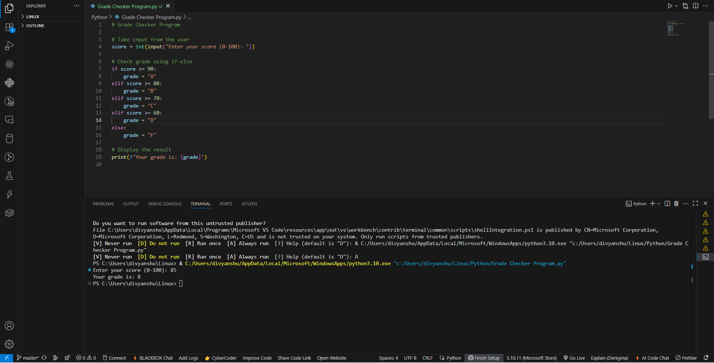

**2 Student Grades**

**Create a dictionary where the keys are student names and the values are their grades. Allow the user to:**

**Add a new student and grade.**

**Update an existing student’s grade.**

**Print all student grades.**

**Used dictionary and basic operations. Using if else:**

**Answer:**

**INPUT:**

# Student Grades Program

# Initialize an empty dictionary

student_grades = {}

while True:

print("\nChoose an option:")

print("1. Add a new student and grade")

print("2. Update an existing student's grade")

print("3. Print all student grades")

print("4. Exit")

choice = input("Enter your choice (1-4): ")

if choice == "1":

name = input("Enter student name: ")

if name in student_grades:

print(f"{name} already exists. Use option 2 to update the grade.")

else:

grade = input("Enter grade: ")

student_grades[name] = grade

print(f"{name} added with grade {grade}.")

elif choice == "2":

name = input("Enter student name to update: ")

if name in student_grades:

grade = input("Enter new grade: ")

student_grades[name] = grade

print(f"{name}'s grade updated to {grade}.")

else:

print(f"{name} does not exist. Use option 1 to add the student.")

elif choice == "3":

if not student_grades:

print("No students in the list.")

else:

print("\nStudent Grades:")

for name, grade in student_grades.items():

print(f"{name}: {grade}")

elif choice == "4":

print("Exiting the program.")

break

else:

print("Invalid choice. Please enter a number between 1 and 4.")

**OUTPUT:**

Choose an option:

1. Add a new student and grade

2. Update an existing student's grade

3. Print all student grades

4. Exit

Enter your choice (1-4): 1

Enter student name: Divyanshu

Enter grade: A

Divyanshu added with grade A.

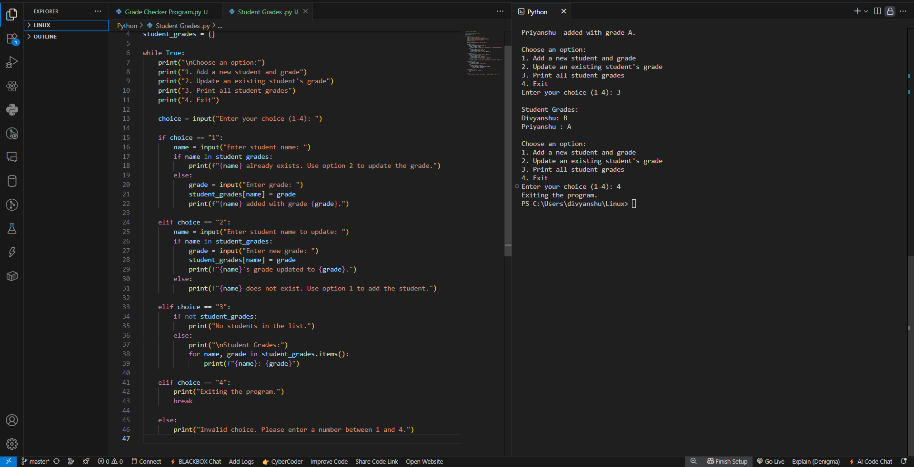

**3.Write to a File**

**Write a program to create a text file and write some content to it.**

**Using file functions like write and open.**

**Answer:**

**INPUT:**

# Create or open a file in write mode

file = open("myfile.txt", "w")

# Write content to the file

file.write("Hello, this is a sample text written to the file.\n")

file.write("This is the second line of the file.")

# Close the file

file.close()

print("Content written successfully to 'myfile.txt'.")

**OUTPUT:**

Hello, this is a sample text written to the file.

This is the second line of the file.

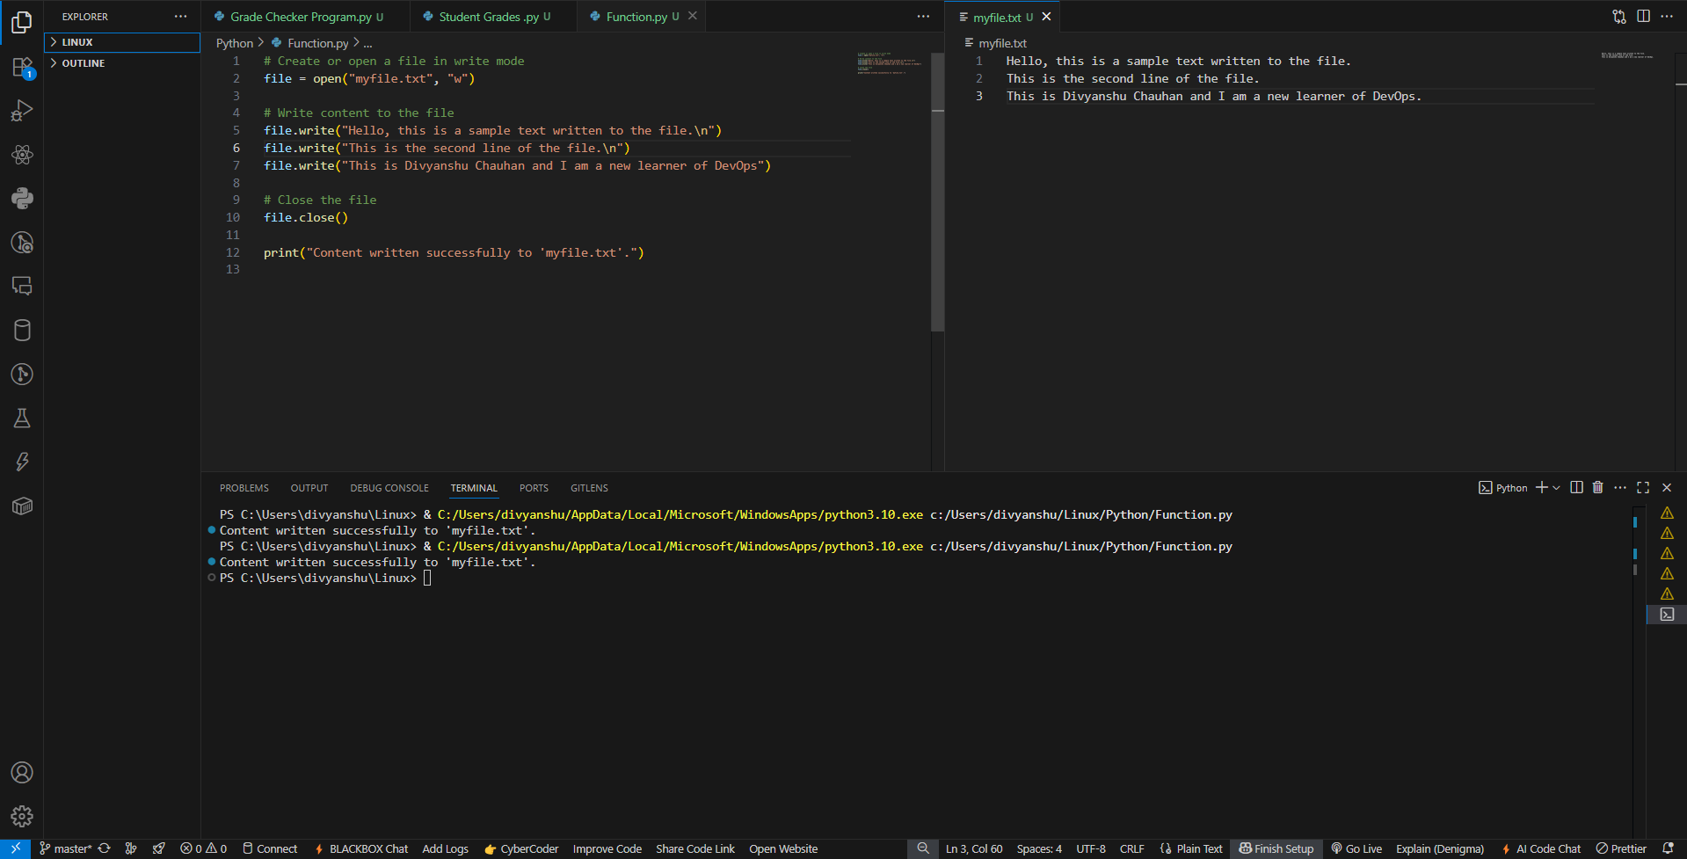

**4. Read from a File**

**We used open in read mode and file.read to read and print to display.**

**Answer:**

# Open the file in read mode

file = open("myfile.txt", "r")

# Read the content of the file

content = file.read()

# Print the content

print("File Content:\n")

print(content)

# Close the file

file.close()

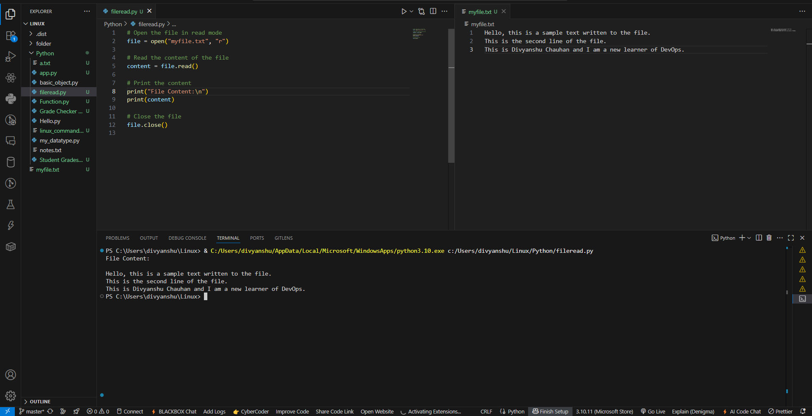

Github Link: